Week 7 Deliverables - Python Local Ran Application Creation

Team ASK
Westcliff University
DATA200 Applied Statistical Analysis
Professor Regmi
February 22, 2026

Week 7 Deliverables - Python Local Ran Application Creation
We created this locally run python based application which predicts a student’s expected study hours and pass/fail status based on key personal, academic, and background factors, providing schools with data-driven insights to support targeted academic interventions, which directly addresses our problem of lacking clear guidance on factors influencing student performance.
Screenshots
Locally ran python application
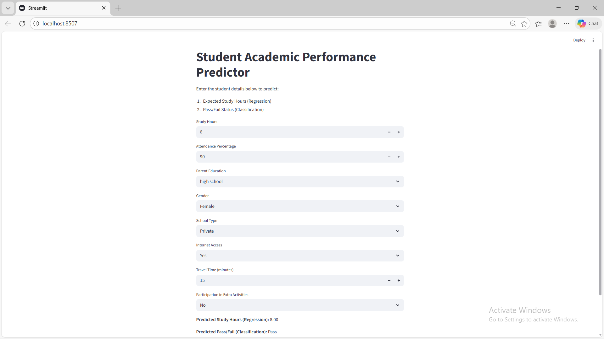

Codes
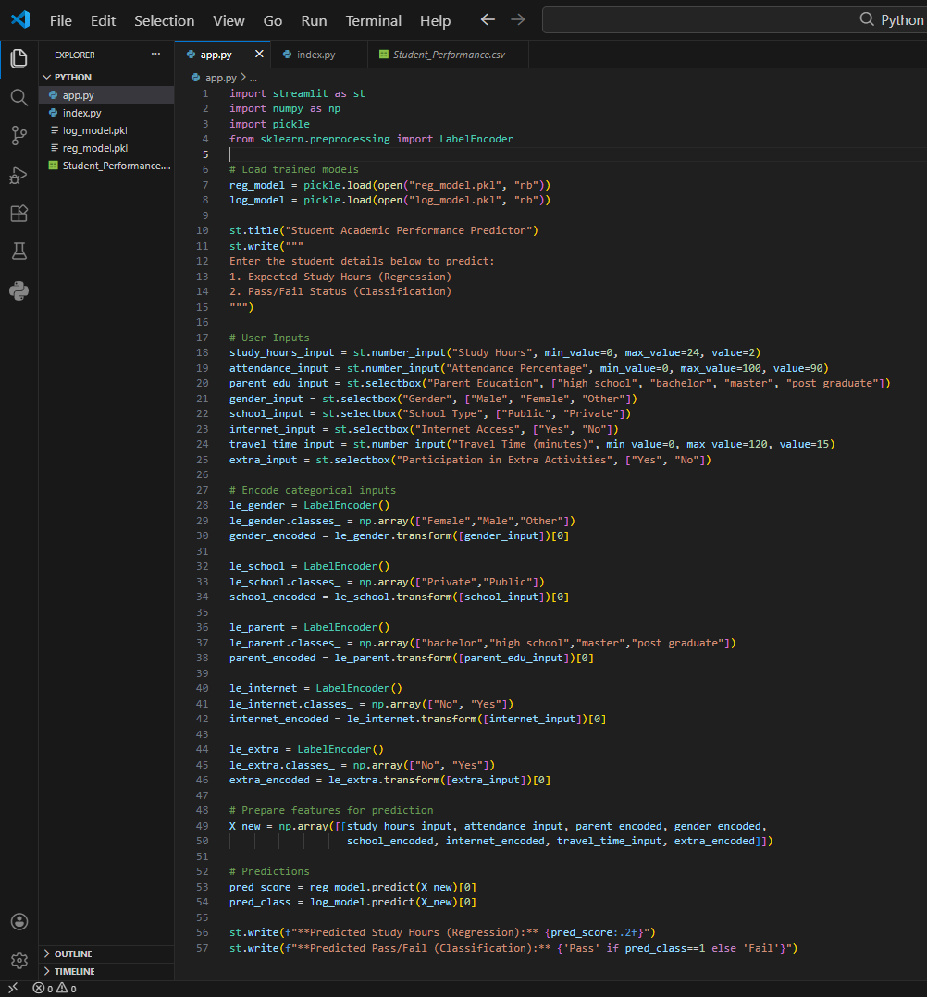
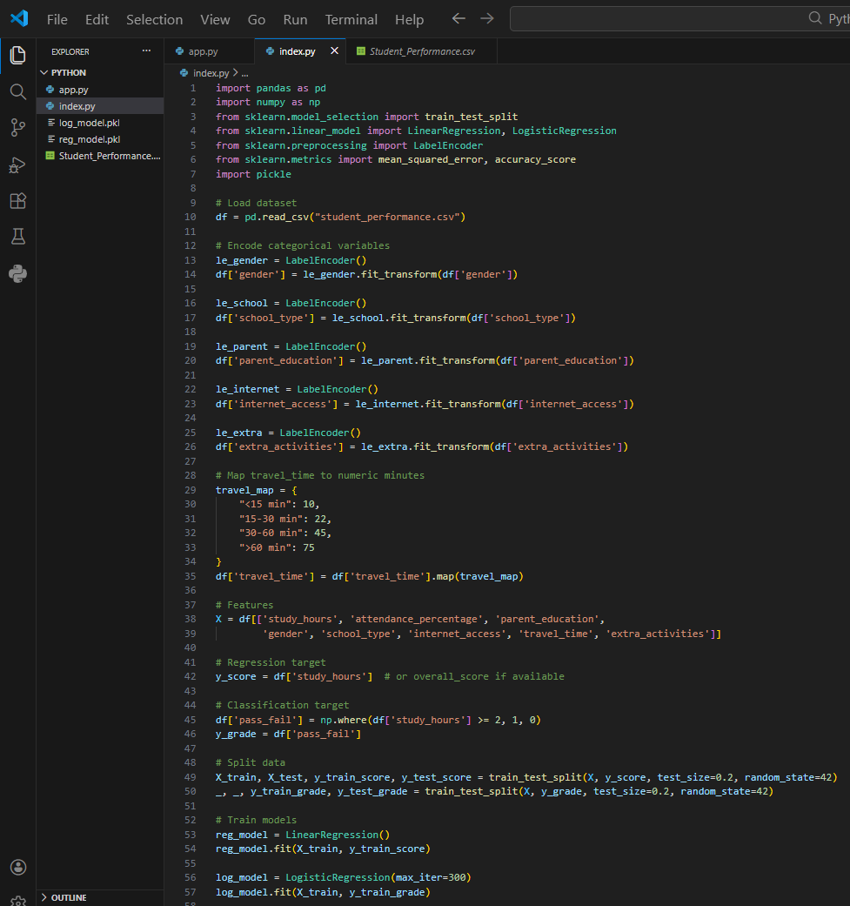

Dataset
